[**https://www.youtube.com/watch?v=8Aw45HN5lnA**](https://www.youtube.com/watch?v=8Aw45HN5lnA)

**Traditional implementation: (using Z-score)**

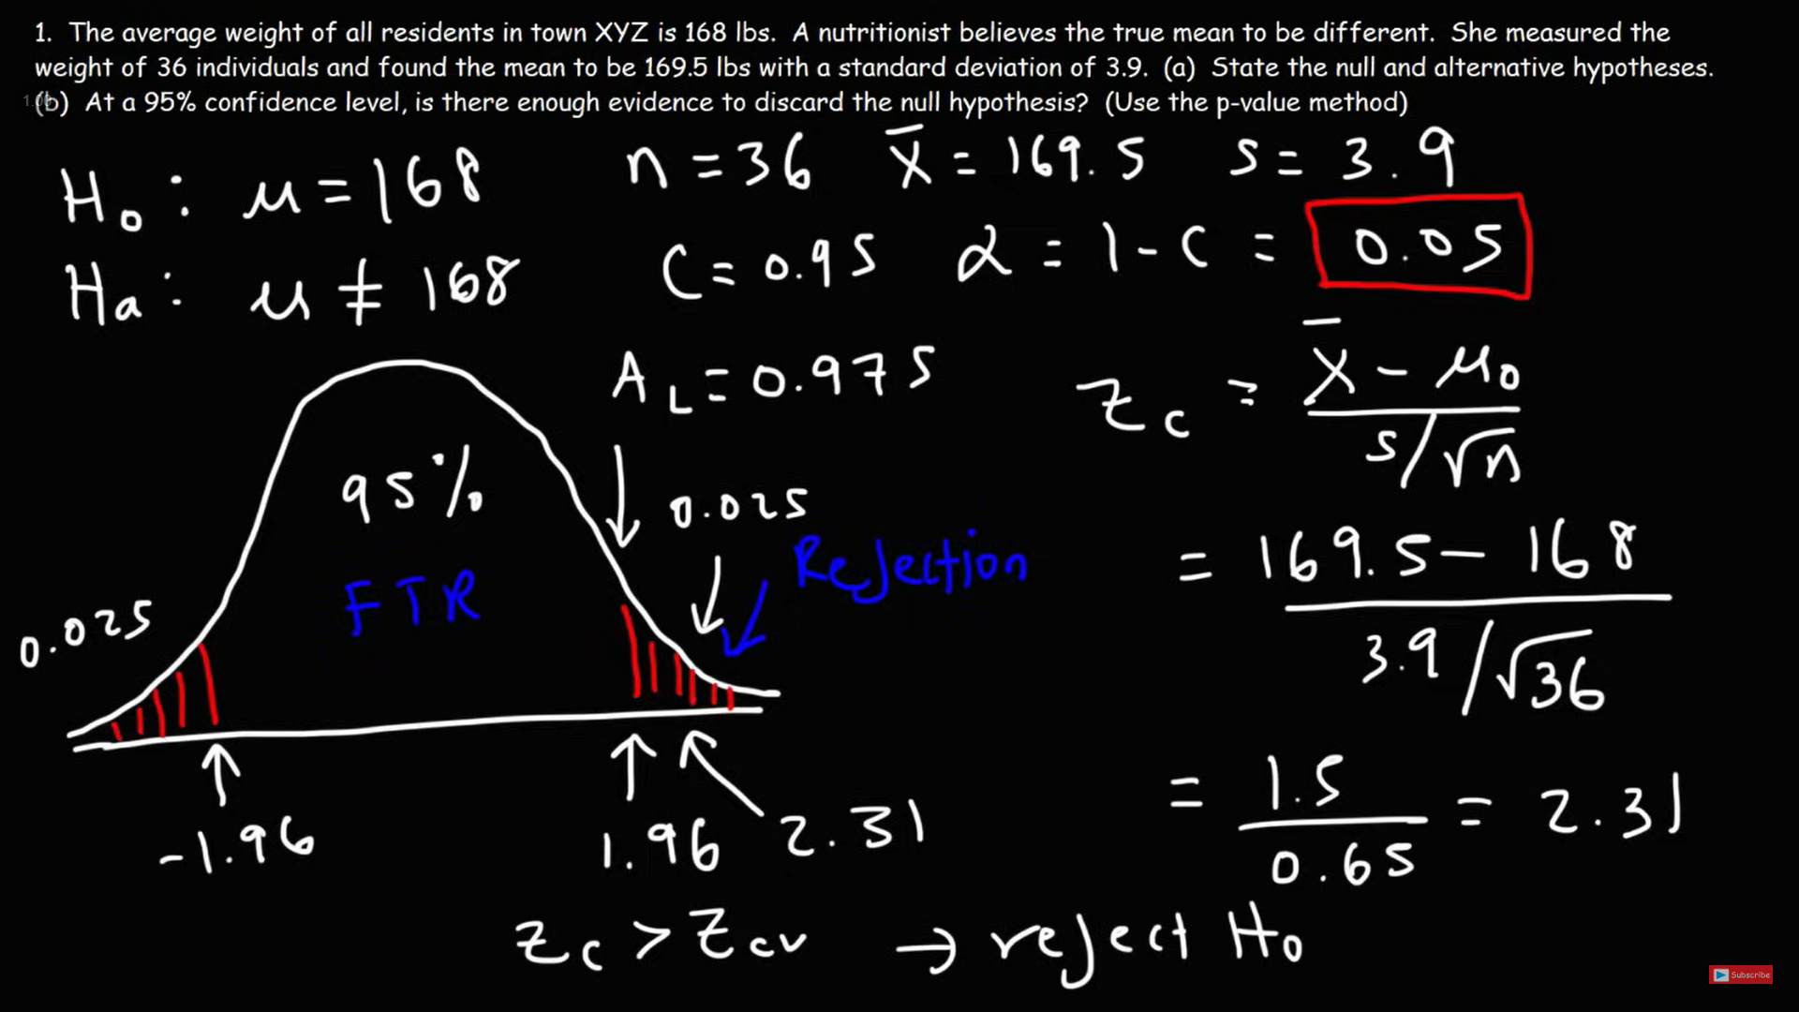

P(Z > 2.31) = 0.01044 (area shaded as red)

Area unshaded as red = 1 – 2*P(Z > 2.31) = 0.97912

P-value = 0.01044*2 = 0.02088

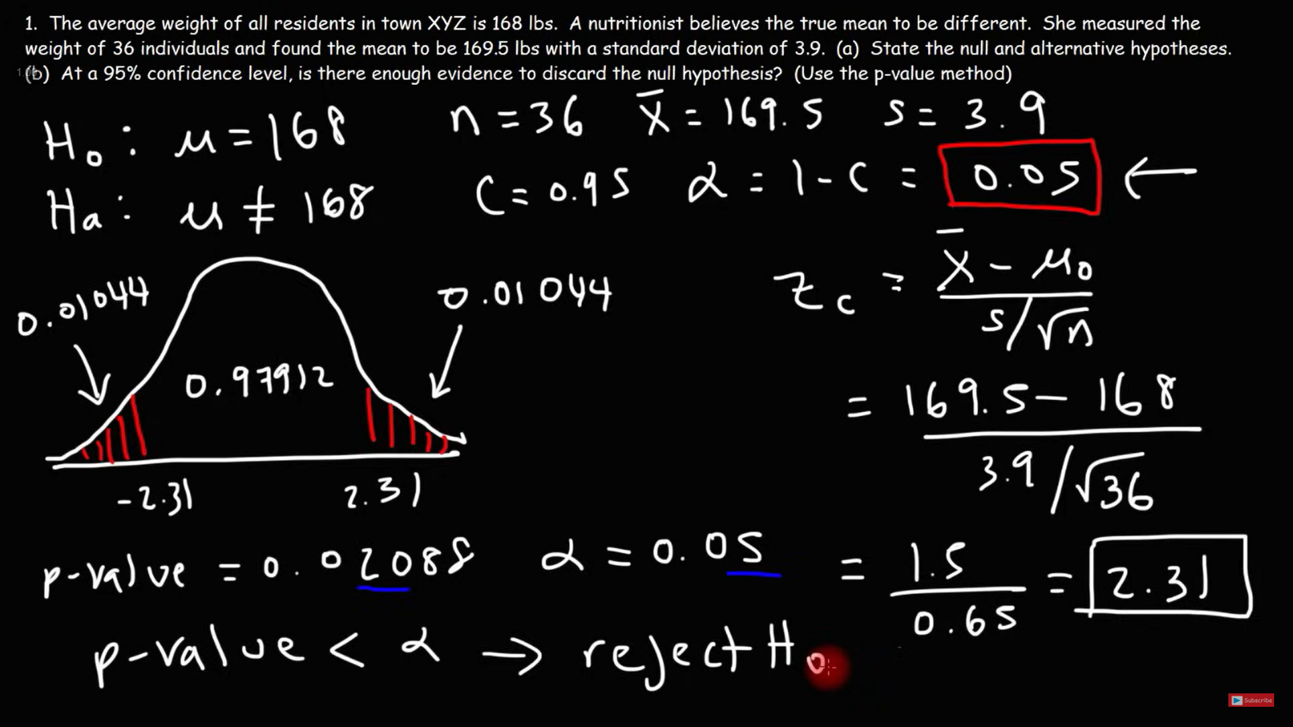

Therefore, with 95% level of confidence, we cannot accept the null hypothesis that the average weight of all residents in town XYZ is 168 lbs.